Exploring Secure Shell

**Task 1: Introduction to SSH**

SSH(Secure Shell) : is a network protocol and cryptographic tool that plays a pivotal role in computer security.
It provides a secure and encrypted method for remote access to networked devices and servers, ensuring the confidentiality and integrity of data during communication.

SSH is important in computer security for several reasons:

- Authentication and Encryption : SSH authenticates users and devices securely. It uses cryptographic techniques to ensure the identity of the connecting parties and encrypts the data exchanged, making it extremely difficult for eavesdroppers to intercept and decipher sensitive information.
- Access Control : SSH provides a means to control and restrict access to networked resources. It allows administrators to grant or deny access based on user credentials, keys, or IP addresses, enhancing access control and protecting against unauthorized access.
- Secure File Transfer : SSH supports secure file transfer mechanisms, such as SCP and SFTP, which enable users to transfer files between local and remote systems in a secure manner. This is essential for securely managing and transferring sensitive data.
- Secure Remote Administration : SSH is a critical tool for remote administration, enabling system administrators to securely manage servers, network devices, and infrastructure remotely. This is particularly important in scenarios where physical access to systems is limited.
- Protection of passwords : SSH reduces the risk of password theft and unauthorized access. It encourages the use of public key authentication, which eliminates the need to transmit passwords over the network and enhances overall security.
- Key Management : SSH's public key infrastructure enables centralized and secure key management. It simplifies access control by allowing administrators to manage user access via the distribution and revocation of public keys.

Real-world Scenarious :

- Secure Server management : System administrators commonly use SSH to securely manage servers and network devices. They can perform tasks like software updates, configuration changes, and troubleshooting remotely without the need for physical access.
- Secure Data Transfer : In the context of secure data exchange, SSH is widely used for transferring files between systems, making it a vital tool for backing up and synchronizing data. Tools like SCP and SFTP enable secure file transfers in various environments.

**Task 2:Key Components of SSH**

Key Components of SSH:

- SSH Client : The SSH client is the software or application used to initiate a secure connection to a remote SSH server. The client initiates the SSH handshake,authenticates the user, and establishes a secure communication channel with the server.
- SSH Server : The SSH server is the remote computer or device that runs SSH server software. It listens for incoming SSH connections, authenticates clients, and grants access to the server or its services. The server can be configured to accept connections from specific users, IP addresses, or groups.
- SSH Protocol : The SSH protocol is the set of rules and conventions that govern how the SSH client and server communicate securely. It defines the format of messages exchanged during the SSH handshake, data encryption and decryption, authentication methods, and other aspects of secure communication.
Role of SSH Keys in Authentication:

- Key Pair : SSH authentication using keys involves a key pair—a public key and a private key. The public key is placed on the remote SSH server, while the private key remains on the user's local machine. The private key is protected with a passphrase.
- Authentication process :
- During authentication,the SSH client encrypts a message using the user’s private key.
- The SSH server decrypts the message using the corresponding public key.
- If the decryption is successful, the server concludes that the client possesses the private key and grant access.

Advantages of SSH Keys :

- Stronger Security : SSH keys provide a higher level of security compared to password-based authentication.
- No Password Transmission : SSH keys eliminate the need to transmit passwords over the network. This reduces the risk of password theft and man-in-the-middle attacks.
- Convenience : Once the key pair is set up, users can authenticate without having to remember and enter passwords.
- MFA Integration : SSH keys can be used in conjunction with multi-factor authentication (MFA), adding an additional layer of security.
- Audit Trail : SSH key-based authentication can be logged and audited, providing an audit trail of who accessed the server and when.
- Scalability : SSH keys are highly scalable, making them suitable for large organizations and systems with many users.

**Task 3: Using SSH (20 points)**

step 1 : Install an SSH Client

- For linux the OpenSSH client is typically pre-installed. You can use the terminal and ssh command.

Step 2 : open your SSH Client

Step 3 : connect to the Remote Server

- In terminal, use the ssh command :
ssh username@server_ip_or_domain
- replace ‘username’ with your SSH username and server_ip with the IP address of the remote server.
Ex : sudo ssh linux@192.168.122.93
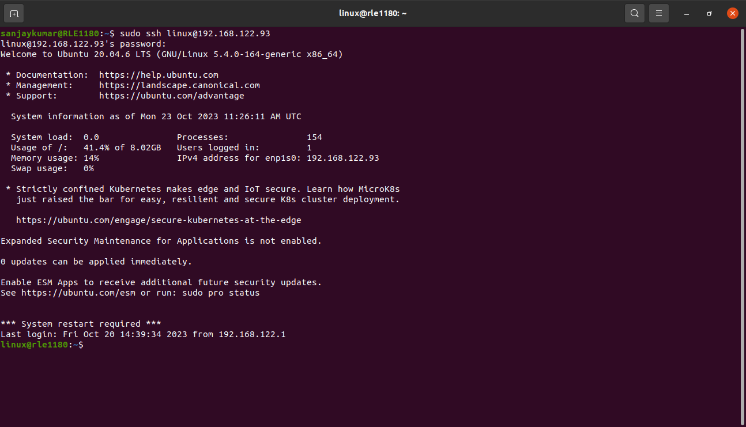
step 5 : Verify Host Key
- you may receive a warning about the authenticity of the host if it’s your first time connecting. Verify the host key if it matches,type “yes” to continue.
Step 6 : Access the Remote Server
- once authenticated,you’ll have access to the remote server,and you can start using it.

**Task 4: File Transfer with SSH**

To use SSH for secure file transfer, you can utilize tools like scp (secure copy) and SFTP (SSH File Transfer Protocol). These tools allow you to transfer files securely between your local machine and a remote server. Here are the steps to transfer a file using scp:
step 1 : use scp to transfer a file to the Remote server
To copy a file from your local machine to the remote server, you can use the scp command.
Syntax :
scp /path/to/local/file username@remote_server:/path/to/remote/location.
- /path/to/local/file : The path to the file you want to transfer from your local machine.
- Username : your SSH username on the remote server.
- remote_server : The IP address or domain of the remote server.
- /path/to/remote/location : The destination path on the remote server
For example,to copy a local file named ‘test4.txt’ to the home directory of the remote server with IP address ‘192.168.122.93’ using the SSH username ‘linux’.
Ex : scp test4.txt linux@192.168.122.93:~
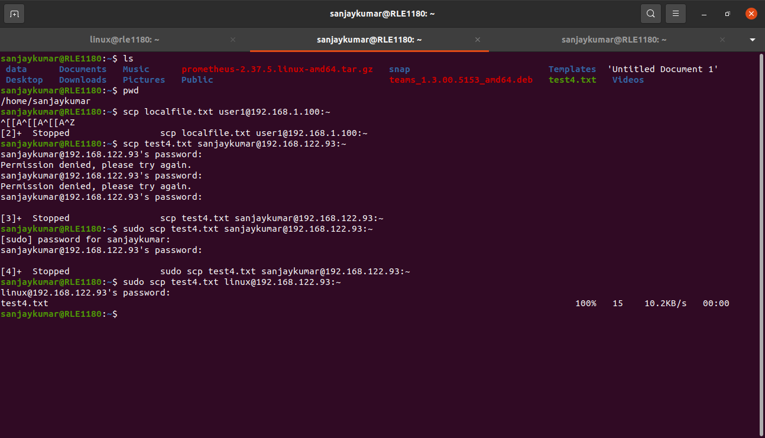
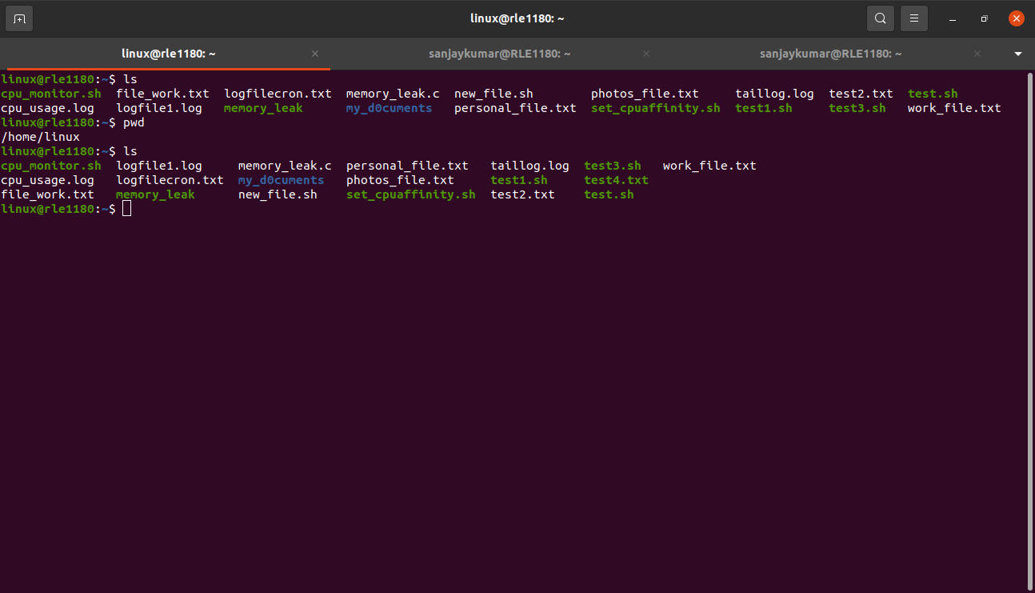

Step 2 : Transfer a File from the Remote Server to your Local Machine

To copy a file from the remote server to your local machine,you can reverse the source and destination paths in the scp command:

syntax :

scp username@remote_server:/path/to/remote/file /path/to/local/destination

For example, to copy a remote file named ‘new_file.sh’ from the home directory of the remote server to your local machine’s /tmp directory.
Ex : scp linux@192.168.122.93:~/new_file.sh /tmp
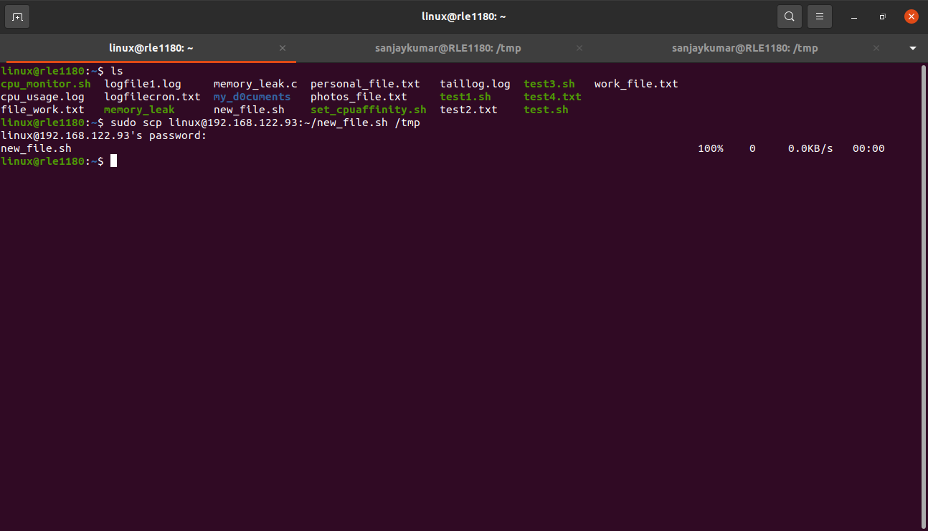

Common Issues and Troubleshooting :

- SSH Key Authentication : If you have set up SSH key authentication, you won't be prompted for a password. Ensure that your SSH key is correctly configured and added to the ~/.ssh/authorized_keys file on the remote server.
- Incorrect Paths : Double-check the paths and file names in the scp command to ensure you are specifying the correct source and destination.
- Permissions : Make sure you have the necessary permissions to read the source file and write to the destination directory on both your local machine and the remote server.

**Task 5: SSH Key Pair Generation **

Step 1: Generate the SSH Key Pair

To generate an SSH key pair, use the ‘ssh-keygen’ command. Run the following command:

sudo ssh-keygen -t rsa -b 2048 -f ~/.ssh/my_ssh_key

Here’s what this command does:
- -t rsa : specifies the key type(RSA).
- -b 2048 : sets the key size to 2048 bits,which is considered secure and widely used.
- -f ~/ .ssh./my_ssh_key : specifies the filename and location where the key pair will be stored.

Step 2 : Set a passphrase (optional)

you can set a passpharse for your SSH key for an additional layer of security. If you choose to set a passphrase,you’ll be prompted to enter it every time you use the key.

Step 3 : confirm Key Generation

The ‘ssh-keygen’ command will generate the key pair and display some information,including the key fingerprint and location where the key is stored.
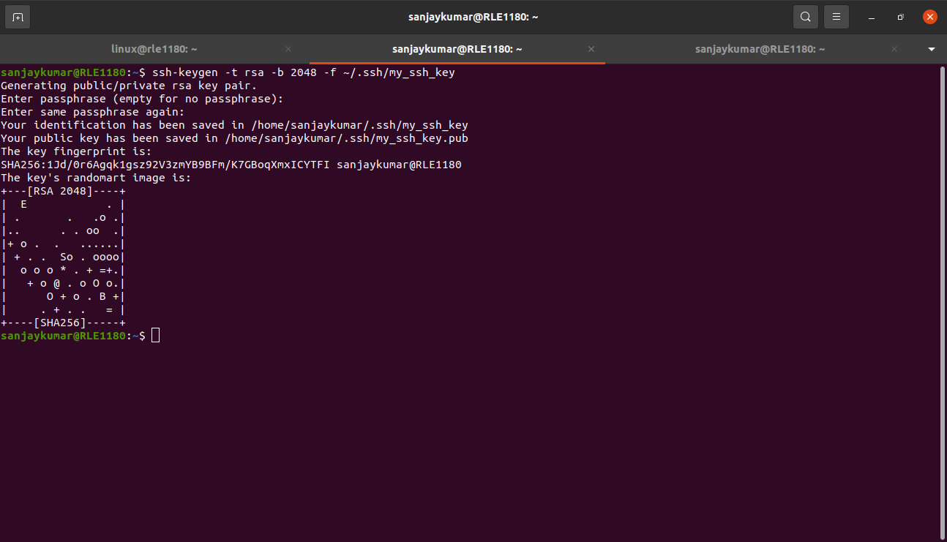
The SSH key pair has been generated, and the public key has been saved as ‘my_ssh_key.pub’ in your ~/.ssh/ directory.

Step 4 : Purpose of SSH Key pairs

- Authentication : The public key is placed on the remote server, while the private key is kept on your local machine. During authentication, the server checks if the public key matches the private key. This method is more secure than using passwords.
- Enhanced Security : SSH key pairs provide stronger security than password-based authentication.
- Key Management : you can centrally manage SSH keys, allowing administrators to add, remove, or update keys for user access.
- Revocation : If a key is compromised, it can be easily revoked and replaced without affecting other users.
- MFA Integration : SSH key authentication can be combined with multi-factor authentication (MFA) for additional security.
- Convenience : Once the key pair is set up, users can authenticate without having to remember and enter passwords.

**Task 6: SSH Authentication**

Step 1: Locate Your SSH Key Pair

your SSH key pair consists of a public key( with .pub extension) and a private key. Ensure you have the private key (my_ssh_key) on your local machine.

Step 2: Configure SSH to Use Your Key Pair

- create a configuration file ~/.ssh/config
Ex : sudo nano ~/.ssh/config

Add the following lines to the configuration file to specify the key file to use for authentication:

Host remote_server
HostName remote_server_address
user your_ssh_username
IdentityFile ~/.ssh/my_ssh_key

- remote_server : label to identify this specific server configuration.
- HostName : The IP address or domain name of the remote server.
- User : Your SSH username on the remote server.
- IdentityFile : The path to your private key (my_ssh_key).

Ex : Host linux_server
HostName 192.168.122.93
User linux
IdentityFile ~/.ssh/my_ssh_key

Step 3: Connect to the remote server using Key-Based Authentication

you can connect to the remote server using key-based authentication. In the terminal, use the ssh command:

Ex : ssh linux_server

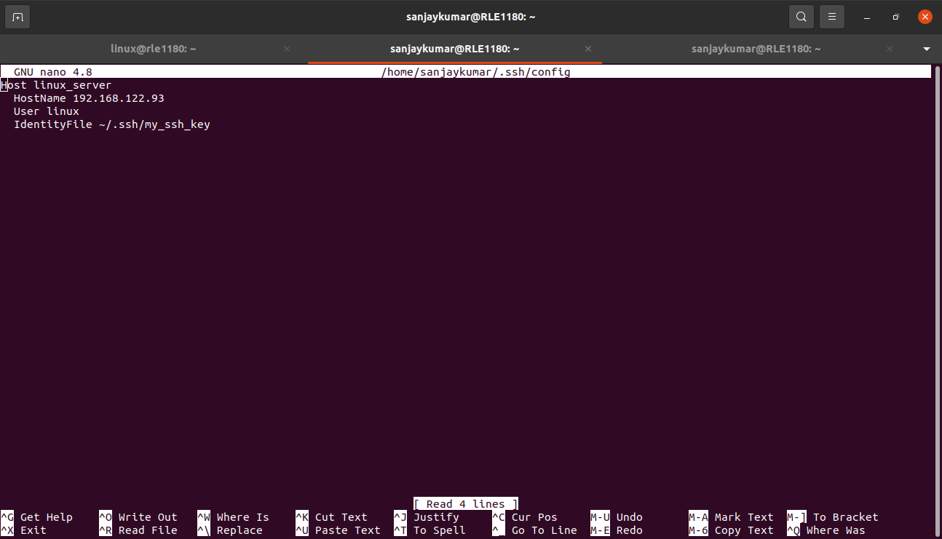
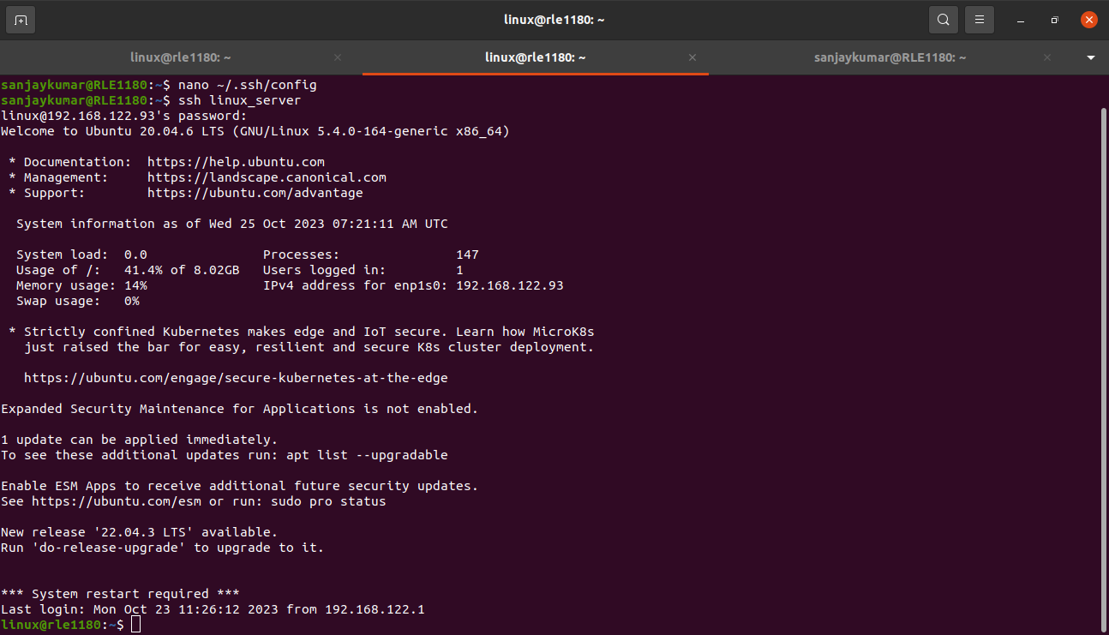

**Task 7: SSH Security Best Practices**

Security best practices when using SSH to connect to remote servers are essential to protect your systems and data.

- Use Key-Based Authentication:

- Importance : Key-based authentication is more secure than password-based authentication. It eliminates the risk of password guessing and brute force attacks. With key-based authentication, even if the private key is stolen, an attacker would still need the passphrase to use it.

2. Disable Root Login:

- Importance : Disabling direct root login via SSH enhances security. Instead of logging in as the root user, you should log in as a regular user and then use ‘sudo’ or ‘su’ to perform administrative tasks. This practice prevents attackers from directly targeting the root account and makes it more difficult to compromise the system.

3.use the strong passwords:
- Importance : If you're using password-based authentication in addition to SSH keys, it's crucial to use strong and unique passwords or passphrases. Strong passwords are resistant to dictionary attacks and password guessing. Consider using a password manager to generate and store complex passwords.

